24/09/2021 26/09/2021 27/09/2021 30/09/2021

China Denmark Education Forum 2021 - Press Release in China Media
- Sohu
https://3g.k.sohu.com/t/n558027031?serialId=c7ce098c17a8e45cd72bbc71944fb1f5&showType=&sf_a=weixin
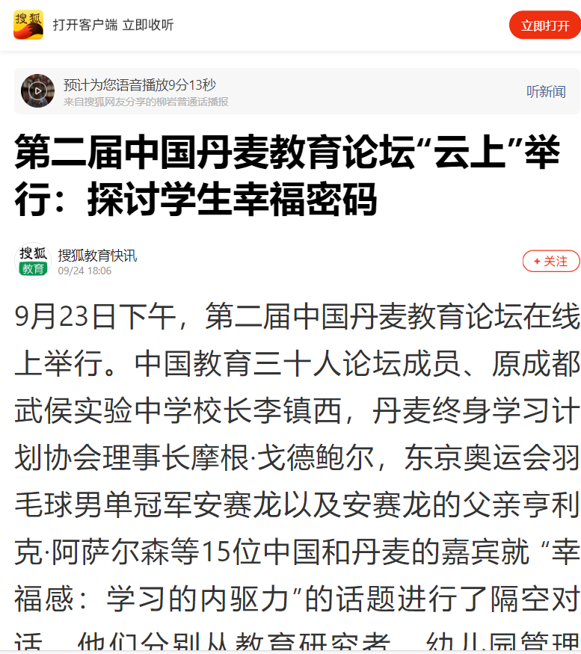

- Global Times
https://lx.huanqiu.com/article/44tqvMlSXqm
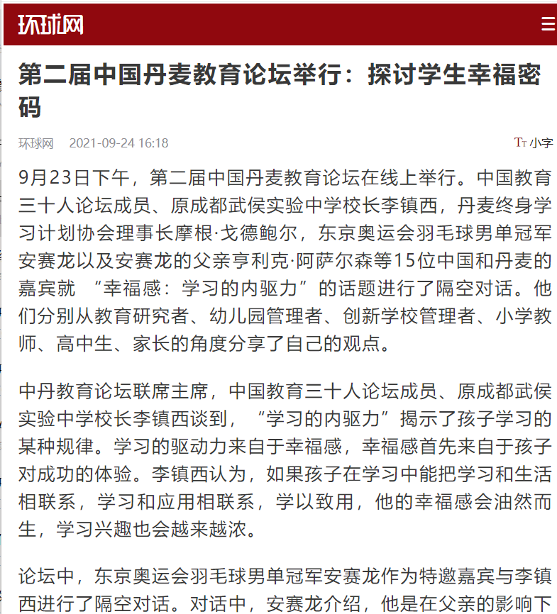
- China.com.cn

http://edu.china.com.cn/2021-09/24/content_77772679.htm

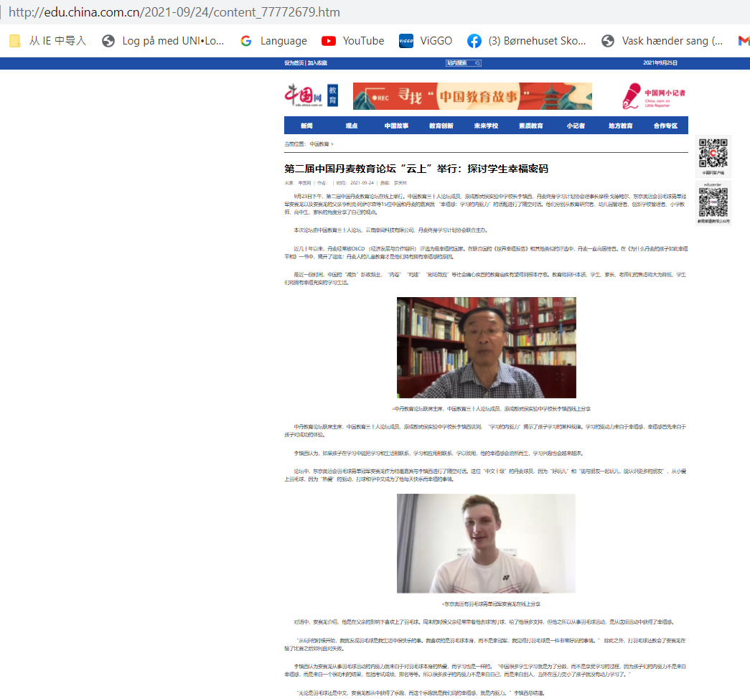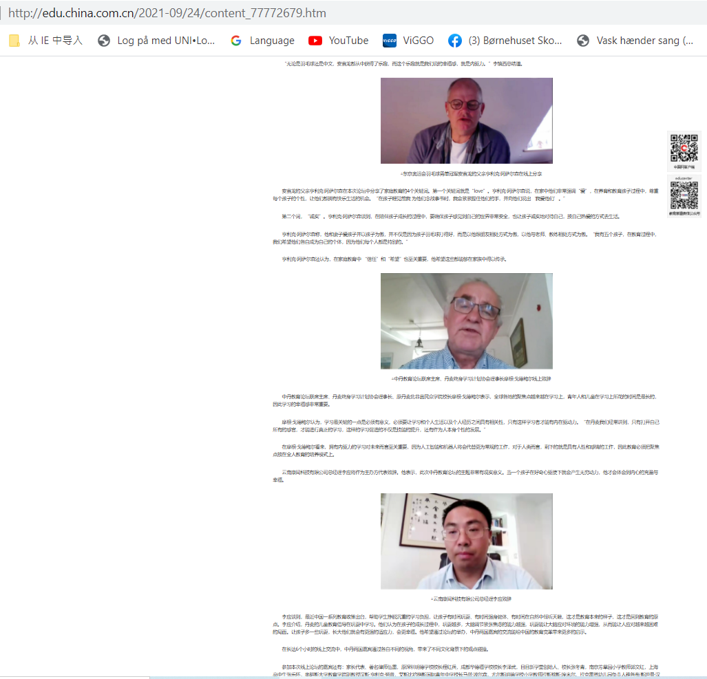
- Tencent
https://view.inews.qq.com/a/AJB2021092408294501?uid=3558842822&shareto=wx&devid=0CFE5059-937D-4B66-AE99-9E0B58974DD0&qimei=0cfe5059-937d-4b66-ae99-9e0b58974dd0&isPro=1&openid=o04IBALcNzZiS5vBin0KduVLUI6E&key=&version=63030532&devicetype=Windows+10+x64&wuid=oDdoCt7NztJ3tbWYqE5iT8h1ERCs

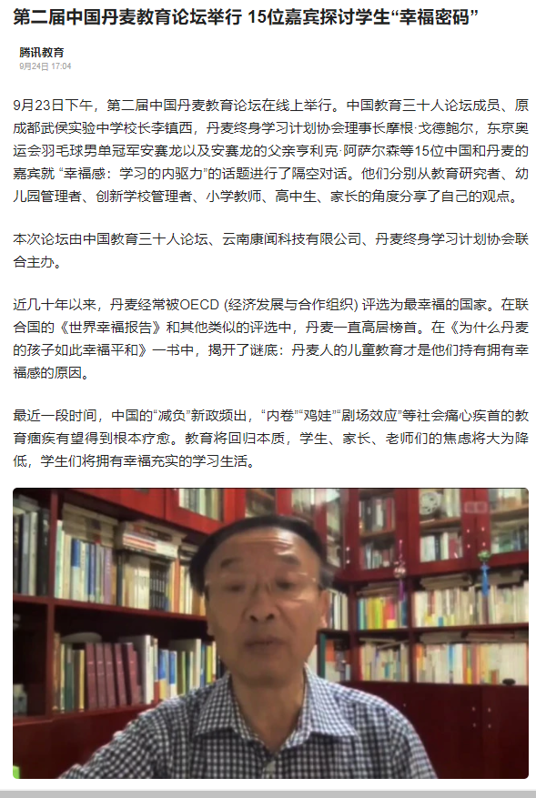

- CE30 – China Eucation 30 Forum
https://mp.weixin.qq.com/s/ZJwsAHHADgVDt7mTdvK80A

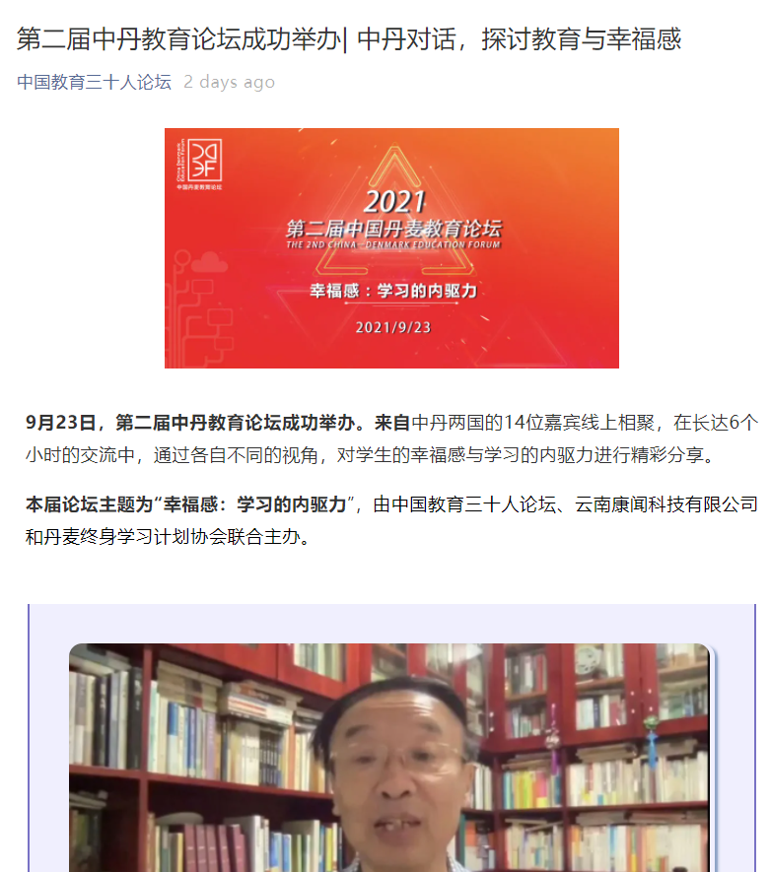

- Modern Education News （published on 'Study and strengthen the nation' App）
https://article.xuexi.cn/articles/index.html?art_id=15052876519505231563&source=share&study_style_id=feeds_opaque&share_to=wx_single&study_share_enable=1&study_comment_disable=0&ptype=0&item_id=15052876519505231563

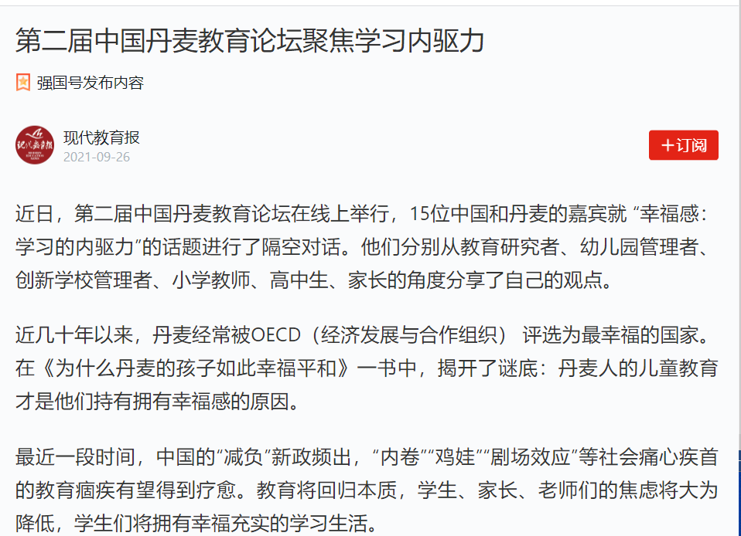

- Sina News
https://edu.sina.com.cn/l/2021-09-26/doc-iktzscyx6445406.shtml

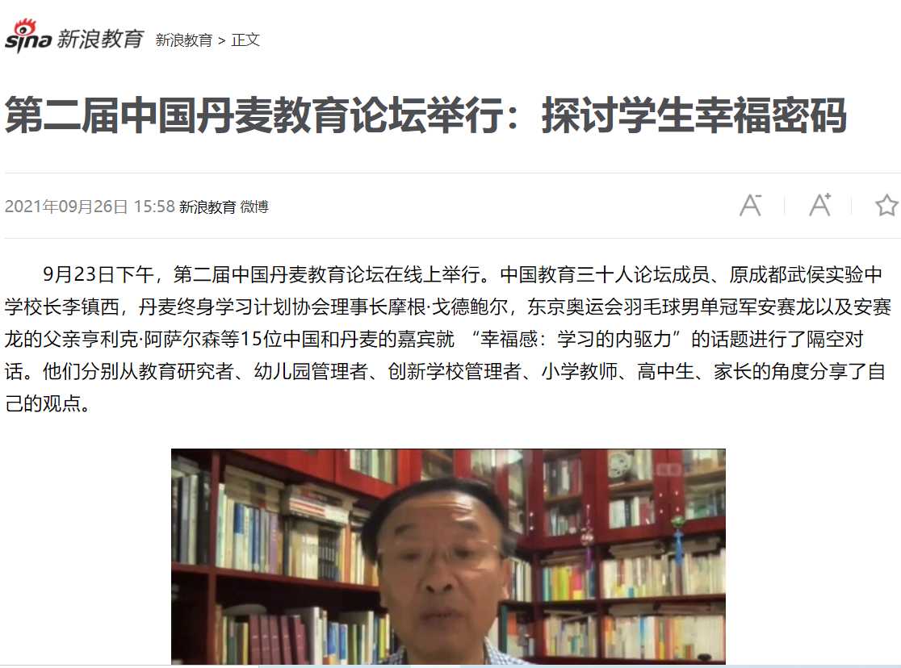

Li Zhenxi & Viktor Dialogue press release in Chinese media

- Sohu
https://3g.k.sohu.com/t/n557831209?serialId=b26080870e6a04214ae38aeb6fb0a57d&showType=&sf_a=weixin

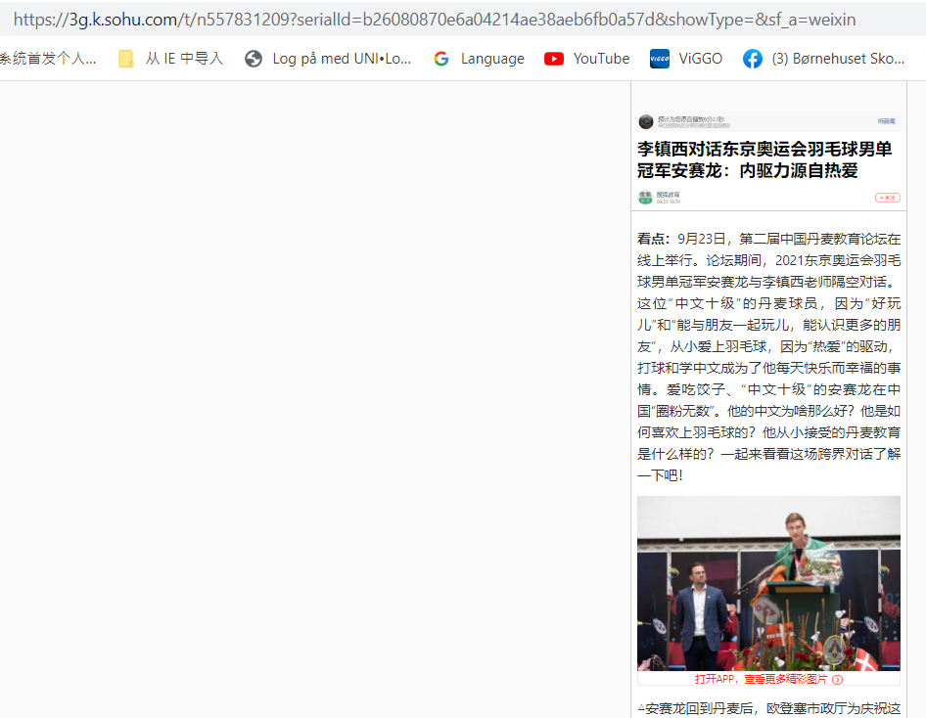
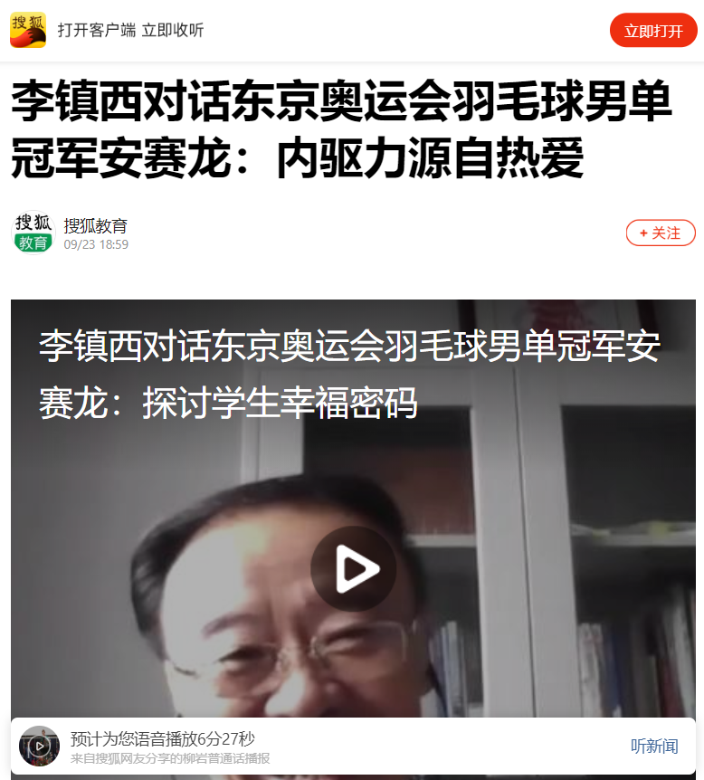

- CE30 - 1
https://mp.weixin.qq.com/s/tyzO6ZJD6SXqBUg9AO5new
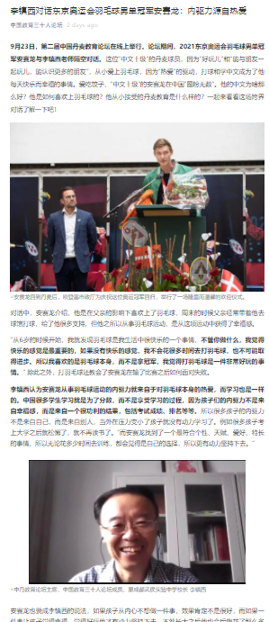

- CE30-2
https://mp.weixin.qq.com/s/-1z70_s5HSIZSNLQWYkgRQ

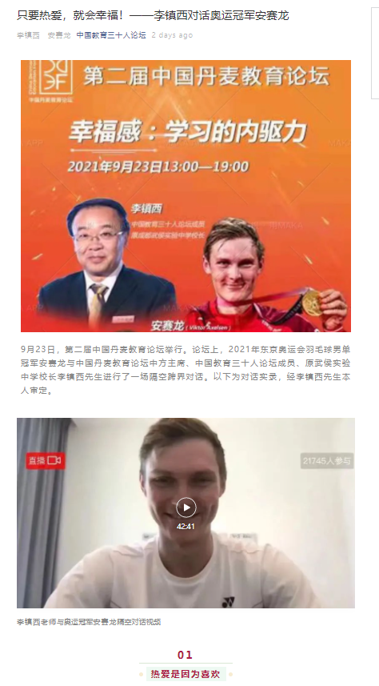
- Li Zhenxi WeChat platform – Zhenxi Tea House
https://mp.weixin.qq.com/s/tBI5YWlOZdhtBIMoZ9y0Mg
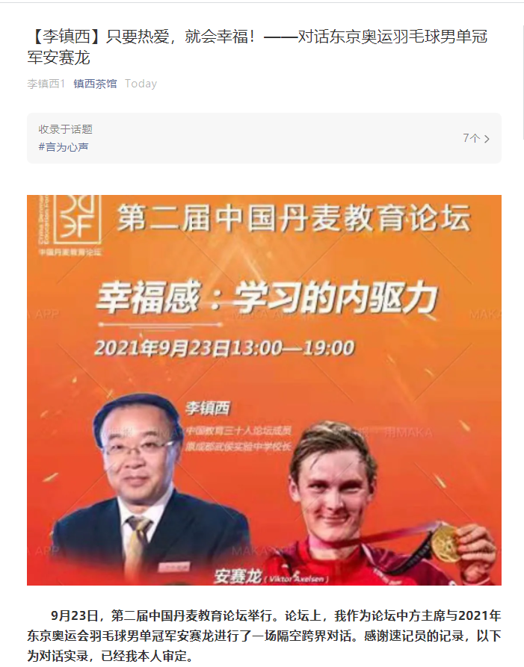

- NetEase
https://3g.163.com/edu/article/GKQ42QHM00297VGM.html?from=dynamic
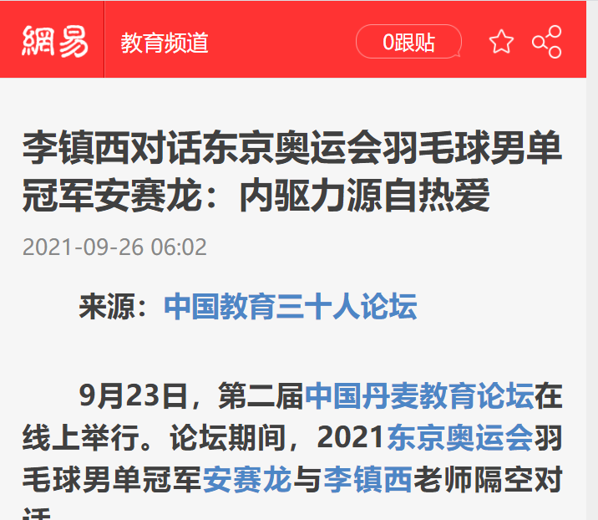

- Toutiao (same family as Tiktok)
https://www.toutiao.com/i7012490323372818956/?wid=1632753940755

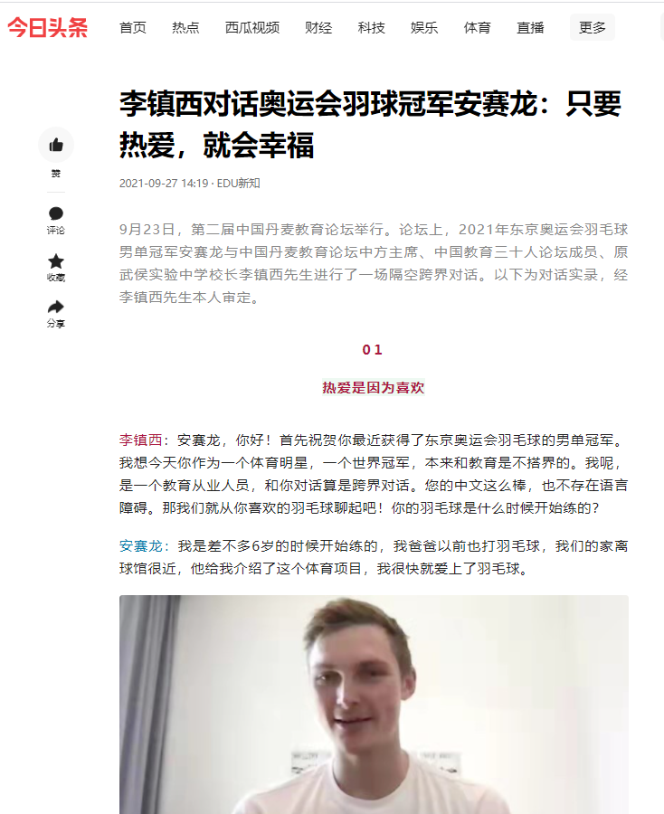

Parent Dialogue

- Sohu
https://3g.k.sohu.com/t/n558279160?serialId=d12d69be85dcf5d007cfec7a367df1f8&showType=&sf_a=weixin
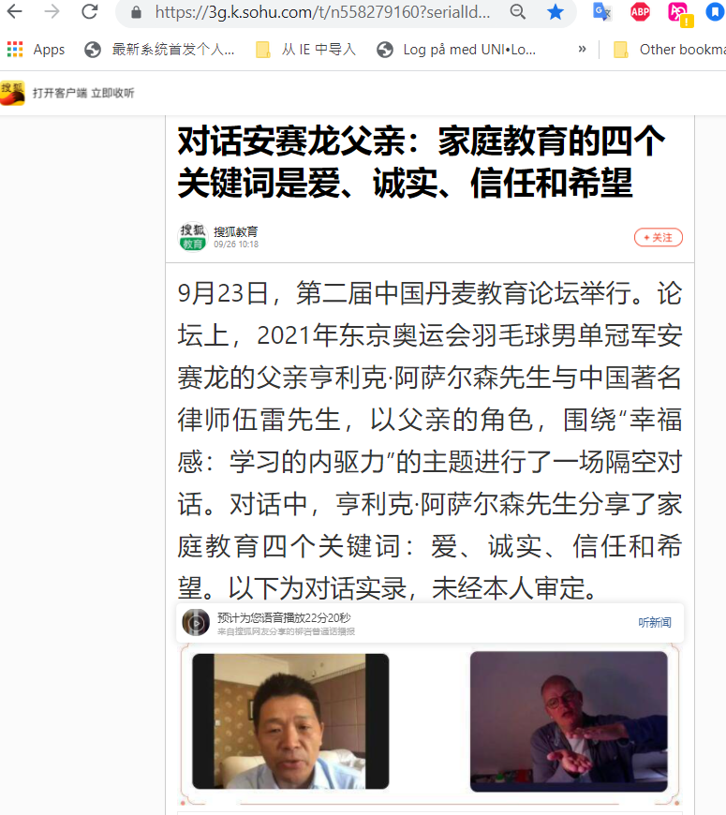

- CE30
https://mp.weixin.qq.com/s/yvcFthMJGvlgSq1eedLRsA
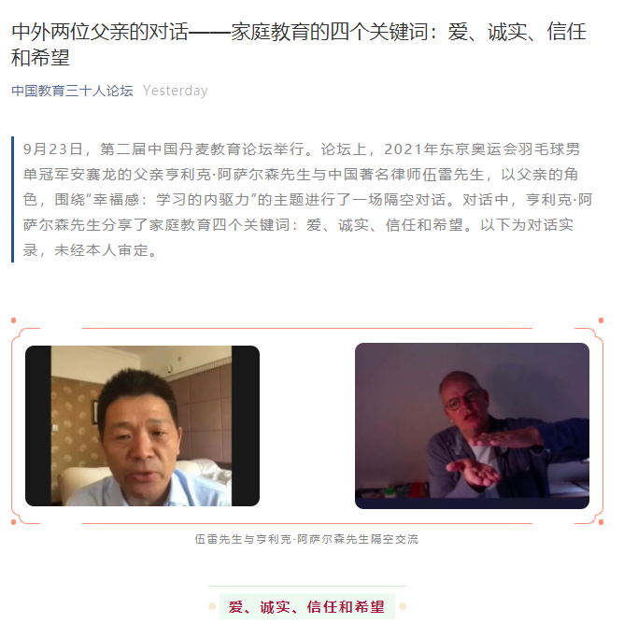
- Netease
https://3g.163.com/edu/article/GKTJMRST00297VGM.html?from=dynamic
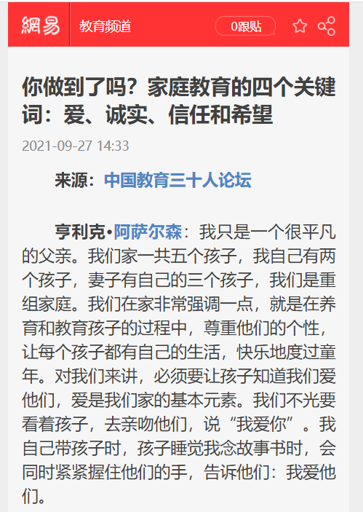

- Contemporary educator media
https://mp.weixin.qq.com/s/7EnMVwTzrhA1lSJCsk6Owg
